Irregular Prism
# Source: AI Source: Provided by: [Data Path: Persons Table -> ID Column: 1, Name_En Column: Motasem Essam] -> From: [ChatGPT] on [7/25/2026]
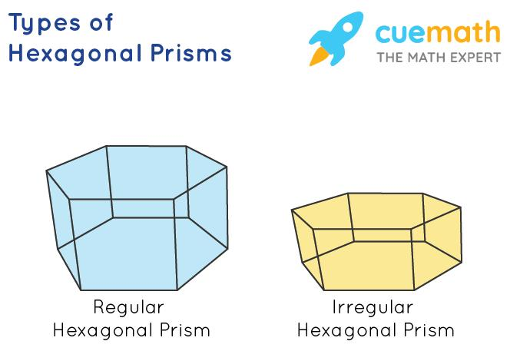
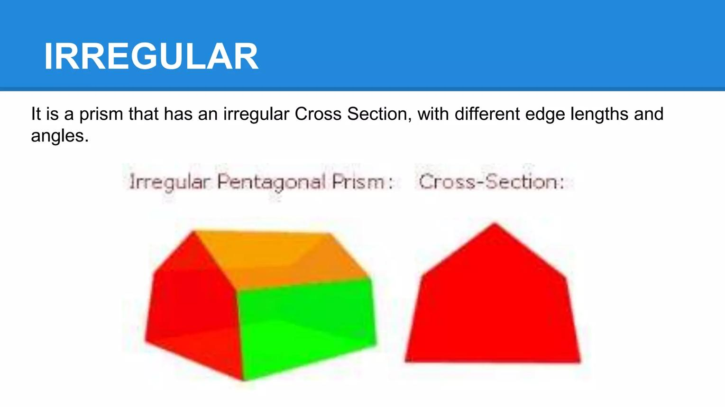
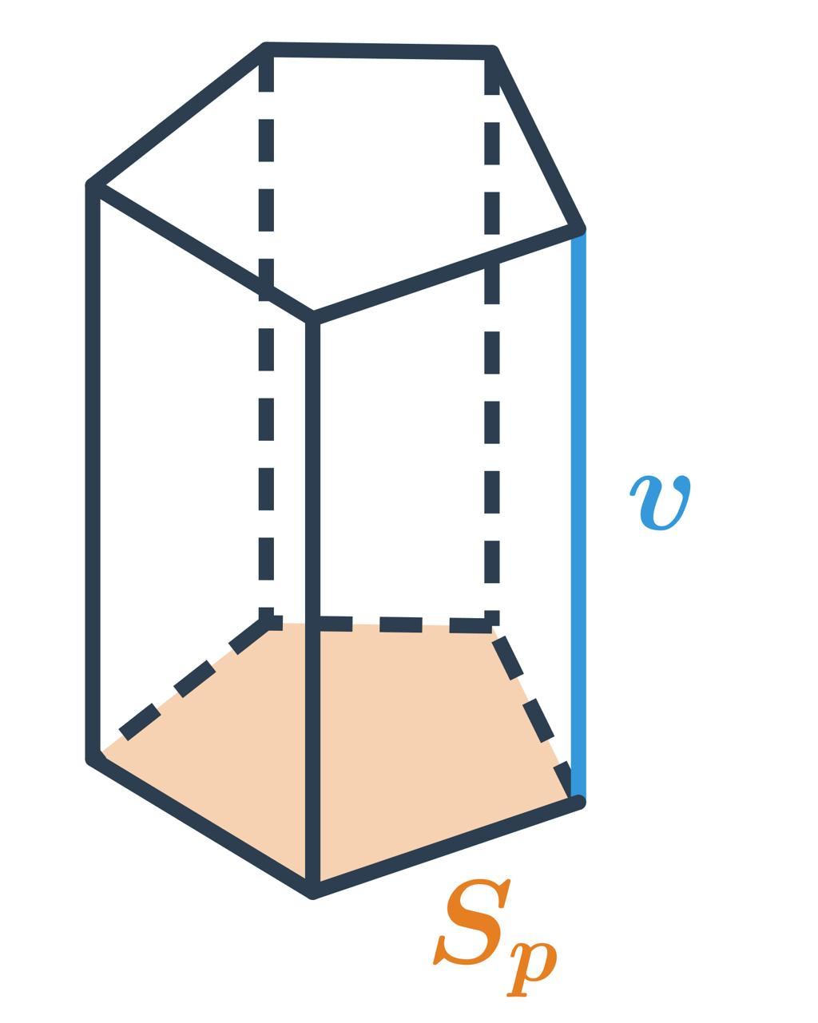

Definition
# Source: AI Source: Provided by: [Data Path: Persons Table -> ID Column: 1, Name_En Column: Motasem Essam] -> From: [ChatGPT] on [7/25/2026]
An irregular prism is a prism whose bases are congruent irregular polygons. An irregular polygon does not have all sides and all interior angles equal.
An irregular prism can be either a right irregular prism, in which the lateral edges are perpendicular to the bases, or an oblique irregular prism, in which the lateral edges are inclined to the bases.
The term irregular prism describes the shape of its bases, not the orientation of the prism.

Simple Definition
# Source: AI Source: Provided by: [Data Path: Persons Table -> ID Column: 1, Name_En Column: Motasem Essam] -> From: [ChatGPT] on [7/25/2026]
An irregular prism is a three-dimensional solid with two identical, parallel polygonal bases that are not regular polygons.

Key Characteristics
# Source: AI Source: Provided by: [Data Path: Persons Table -> ID Column: 1, Name_En Column: Motasem Essam] -> From: [ChatGPT] on [7/25/2026]
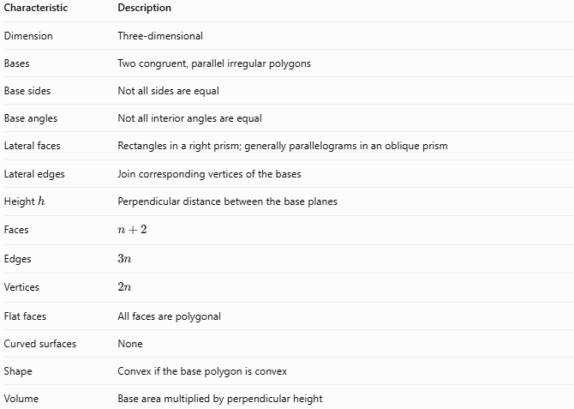
Characteristic | Description
Dimension | Three-dimensional
Bases | Two congruent, parallel irregular polygons
Base sides | Not all sides are equal
Base angles | Not all interior angles are equal
Lateral faces | Rectangles in a right prism; generally parallelograms in an oblique prism
Lateral edges | Join corresponding vertices of the bases
Height $h$ | Perpendicular distance between the base planes
Faces | $$n+2$$
Edges | $$3n$$
Vertices | $$2n$$
Flat faces | All faces are polygonal
Curved surfaces | None
Shape | Convex if the base polygon is convex
Volume | Base area multiplied by perpendicular height
Here, $n$ is the number of sides of each base polygon. An irregular base may be concave, too, but the prism's geometry and convexity then need to be considered accordingly.

Geometric Representation
# Source: AI Source: Provided by: [Data Path: Persons Table -> ID Column: 1, Name_En Column: Motasem Essam] -> From: [ChatGPT] on [7/25/2026]
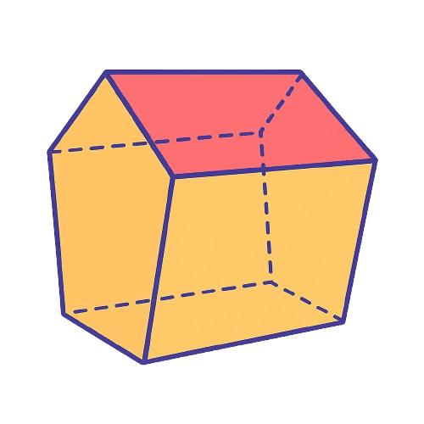
An irregular prism consists of three main components:
- Base faces: Two congruent irregular polygons on parallel planes.
- Lateral faces: The side faces joining corresponding edges of the bases.
- Lateral edges: The segments connecting corresponding base vertices.
In a right irregular prism, the lateral edges are perpendicular to the bases, but the base edges may have different lengths and the base angles may differ.
Examples by base polygon
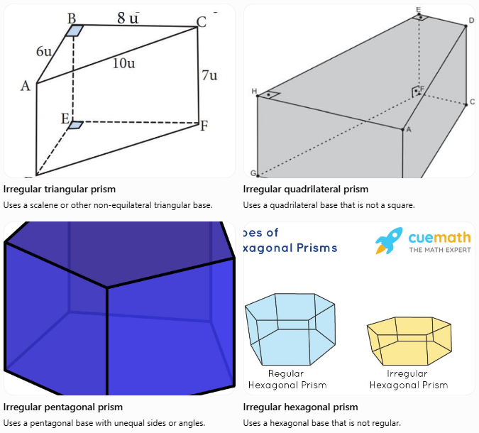
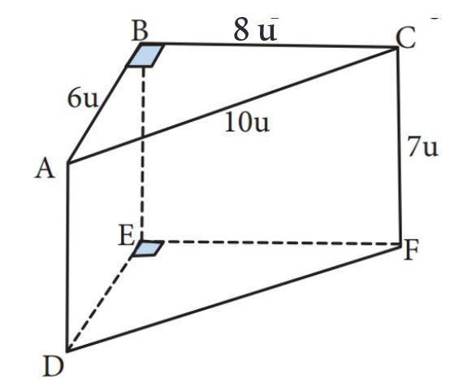
Irregular triangular prism
Uses a scalene or other non-equilateral triangular base.
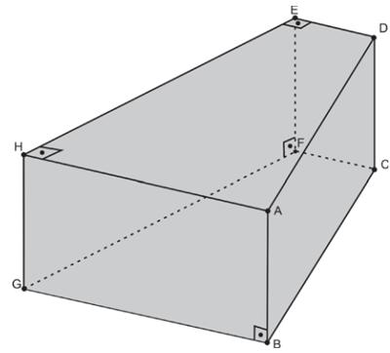
Irregular quadrilateral prism
Uses a quadrilateral base that is not a square.
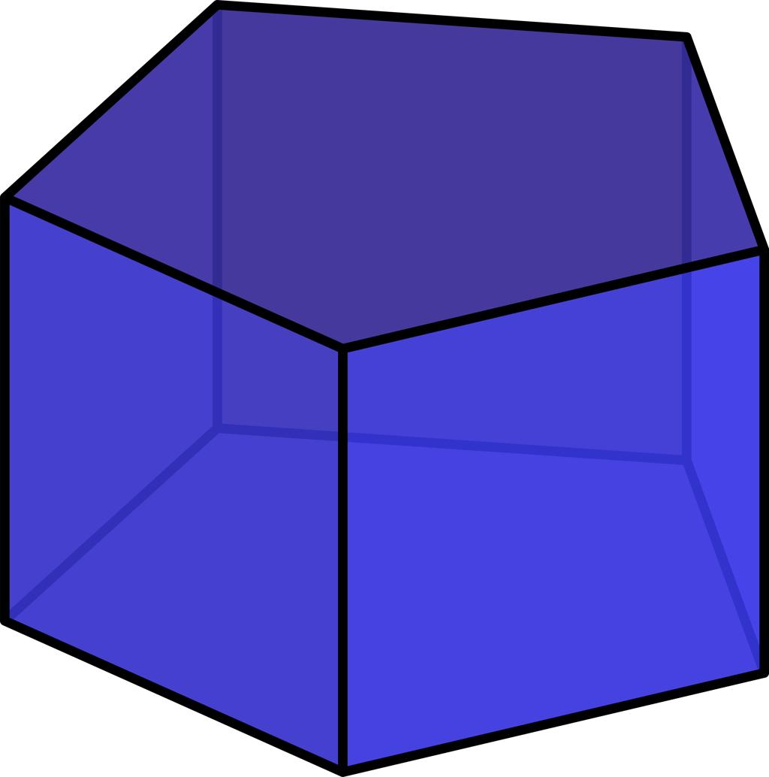
Irregular pentagonal prism
Uses a pentagonal base with unequal sides or angles.
Irregular hexagonal prism
Uses a hexagonal base that is not regular.

6. Mathematical Representations and Formulas
# Source: AI Source: Provided by: [Data Path: Persons Table -> ID Column: 1, Name_En Column: Motasem Essam] -> From: [ChatGPT] on [7/25/2026]
Let:
- $n$ = number of sides of each base.
- $B$ = area of one base.
- $P$ = perimeter of the base.
- $h$ = perpendicular distance between the bases.
- $a_{1},a_{2},…,a_{n}$ = the individual base side lengths.

Number of Faces, Edges, and Vertices
# Source: AI Source: Provided by: [Data Path: Persons Table -> ID Column: 1, Name_En Column: Motasem Essam] -> From: [ChatGPT] on [7/25/2026]
For an $n$-gonal prism:
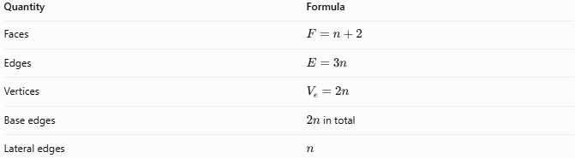
Quantity | Formula
Faces | $$F=n+2$$
Edges | $$E=3n$$
Vertices | $$V_{e}=2n$$
Base edges | $2n$ in total
Lateral edges | $$n$$
These counts do not depend on whether the base polygon is regular or irregular.
Euler's formula applies to a convex prism:
$$V_{e}-E+F=2$$
Substituting the formulas:
$$2n-3n+\left(n+2\right)=2$$

Perimeter of the Base
# Source: AI Source: Provided by: [Data Path: Persons Table -> ID Column: 1, Name_En Column: Motasem Essam] -> From: [ChatGPT] on [7/25/2026]
Since the base sides may have different lengths:
$$\boxed{P=a_{1}+a_{2}+⋯+a_{n}}$$
Unlike a regular prism, the perimeter generally cannot be simplified to $na$ using a single common side length.

Base Area
# Source: AI Source: Provided by: [Data Path: Persons Table -> ID Column: 1, Name_En Column: Motasem Essam] -> From: [ChatGPT] on [7/25/2026]
The base area depends on the specific irregular polygon. It may be calculated by:
- Dividing the polygon into triangles or simpler shapes.
- Adding or subtracting rectangle and triangle areas.
- Using the coordinate-based shoelace formula for a polygon with known vertices.
For example, if an irregular quadrilateral is divided into two triangles with areas $B_{1}$ and $B_{2}$:
$$\boxed{B=B_{1}+B_{2}}$$

Volume
# Source: AI Source: Provided by: [Data Path: Persons Table -> ID Column: 1, Name_En Column: Motasem Essam] -> From: [ChatGPT] on [7/25/2026]
For both right and oblique prisms, volume uses the perpendicular distance between the base planes:
$$\boxed{V=Bh}$$

Lateral Surface Area
# Source: AI Source: Provided by: [Data Path: Persons Table -> ID Column: 1, Name_En Column: Motasem Essam] -> From: [ChatGPT] on [7/25/2026]
For a right irregular prism, the lateral faces are rectangles, so:
$$\boxed{A_{L}=Ph}$$
For an oblique irregular prism, this formula generally does not apply. Instead, calculate the area of each lateral parallelogram and add them:
$$\boxed{A_{L}=\sum_{i=1}^{n}{A_{i}}}$$
where $A_{i}$ is the area of the $i$-th lateral face.

Total Surface Area
# Source: AI Source: Provided by: [Data Path: Persons Table -> ID Column: 1, Name_En Column: Motasem Essam] -> From: [ChatGPT] on [7/25/2026]
For a closed prism:
$$\boxed{A_{T}=2B+A_{L}}$$
For a right irregular prism, this becomes:
$$\boxed{A_{T}=2B+Ph}$$

Worked Examples
# Source: AI Source: Provided by: [Data Path: Persons Table -> ID Column: 1, Name_En Column: Motasem Essam] -> From: [ChatGPT] on [7/25/2026]
Example 1: Volume of a Right Irregular Prism
A right irregular prism has a base composed of two triangles with areas $12{\text{ cm}}^{2}$ and $8{\text{ cm}}^{2}$. Its height is $10\text{ cm}$. Find its volume.
Step 1: Calculate the base area.
$$B=12+8=20{\text{ cm}}^{2}$$
Step 2: Calculate the volume.
$$V=Bh=20\left(10\right)$$
$$\boxed{V=200{\text{ cm}}^{3}}$$
Example 2: Lateral and Total Surface Areas
A right irregular prism has a base area of $30{\text{ cm}}^{2}$, a base perimeter of $26\text{ cm}$, and a height of $7\text{ cm}$. Find its lateral and total surface areas.
Step 1: Lateral surface area
$$A_{L}=Ph=26\left(7\right)$$
$$\boxed{A_{L}=182{\text{ cm}}^{2}}$$
Step 2: Total surface area
$$A_{T}=2B+A_{L}$$
$$A_{T}=2\left(30\right)+182$$
$$\boxed{A_{T}=242{\text{ cm}}^{2}}$$
Example 3: Count Faces, Edges, and Vertices
An irregular pentagonal prism has a pentagonal base, so $n=5$.
- Faces: $F=5+2=\boxed{7}$
- Edges: $E=3\left(5\right)=\boxed{15}$
- Vertices: $V_{e}=2\left(5\right)=\boxed{10}$
These counts are identical to those of a regular pentagonal prism.

Comparison with Related Types of Prisms
# Source: AI Source: Provided by: [Data Path: Persons Table -> ID Column: 1, Name_En Column: Motasem Essam] -> From: [ChatGPT] on [7/25/2026]
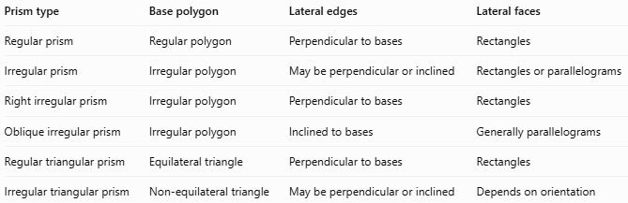
Prism type | Base polygon | Lateral edges | Lateral faces
Regular prism | Regular polygon | Perpendicular to bases | Rectangles
Irregular prism | Irregular polygon | May be perpendicular or inclined | Rectangles or parallelograms
Right irregular prism | Irregular polygon | Perpendicular to bases | Rectangles
Oblique irregular prism | Irregular polygon | Inclined to bases | Generally parallelograms
Regular triangular prism | Equilateral triangle | Perpendicular to bases | Rectangles
Irregular triangular prism | Non-equilateral triangle | May be perpendicular or inclined | Depends on orientation
Key distinction: Regularity describes the base polygon, while right or oblique describes the prism's spatial orientation. These are separate classification properties.

Applications of Irregular Prisms
# Source: AI Source: Provided by: [Data Path: Persons Table -> ID Column: 1, Name_En Column: Motasem Essam] -> From: [ChatGPT] on [7/25/2026]
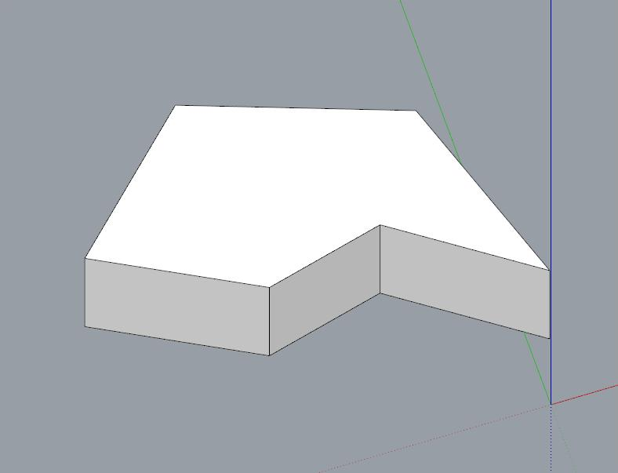
Architecture
Buildings with irregular polygonal floor plans can have prism-like forms when their footprints extend vertically.
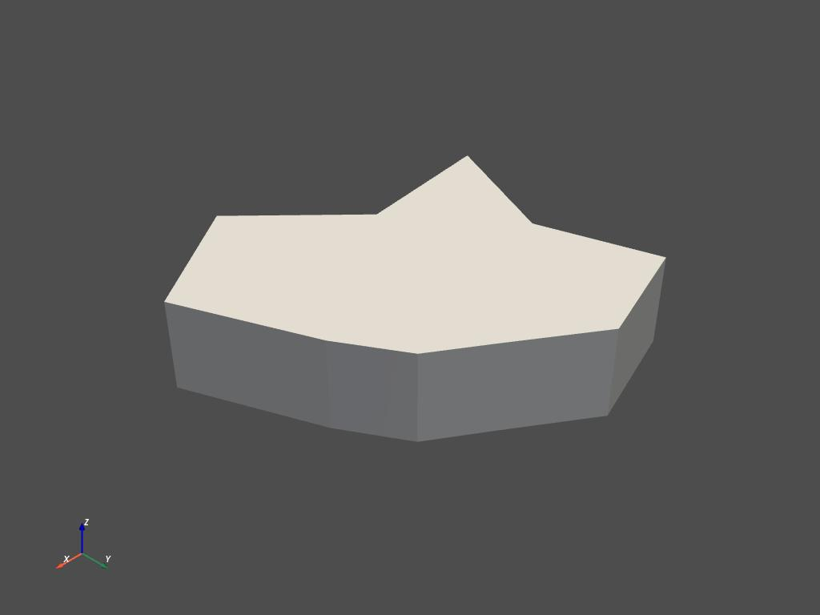
Engineering and manufacturing
Extruded components with nonuniform polygonal cross-sections can be modeled and measured using prism geometry.

Packaging
Custom-shaped boxes and containers may use irregular polygonal cross-sections to fit particular products.
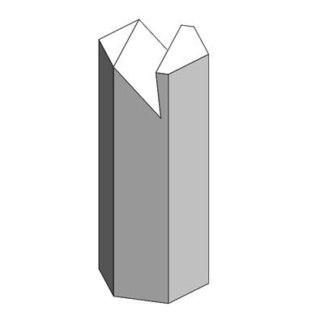
Mathematics and computer graphics
Irregular prisms provide examples for studying polygon area, volume, surface area, and three-dimensional modeling.

Key Points
# Source: AI Source: Provided by: [Data Path: Persons Table -> ID Column: 1, Name_En Column: Motasem Essam] -> From: [ChatGPT] on [7/25/2026]
- An irregular prism has two congruent, parallel irregular polygon bases.
- The bases do not have all sides and all interior angles equal.
- An irregular prism can be right or oblique.
- For an $n$-gonal prism, the number of faces is $n+2$, the number of edges is $3n$, and the number of vertices is $2n$.
- Its volume is $V=Bh$.
- For a right irregular prism, lateral surface area is $A_{L}=Ph$.
- For an oblique prism, lateral surface area is generally calculated by adding the areas of its lateral faces.
- A regular prism and an irregular prism have the same general formulas for counting faces, edges, and vertices.

Conclusion
# Source: AI Source: Provided by: [Data Path: Persons Table -> ID Column: 1, Name_En Column: Motasem Essam] -> From: [ChatGPT] on [7/25/2026]
An irregular prism is a polyhedron with two identical, parallel irregular polygon bases. Its base shape determines whether it is triangular, quadrilateral, pentagonal, hexagonal, or another type of prism. Its orientation determines whether it is right or oblique. Understanding these two classifications helps in choosing the correct formulas for volume and surface area.

